**PORTFOLIO**

**COMPUTER SCIENCE AND ENGINEERING**

Submitted by:

Name: Pahulmeet Singh

Registration number: 12406443

Section: K24CT

Roll No.: 04

**Submitted to: Dr. Joshva Raj G.**



**LOVELY PROFESSIONAL UNIVERSITY**

**DECLARATION**

I, Pahulmeet Sinh, a student of Bachelor of Technology under CSE discipline at Lovely Professional University, Punjab, hereby declare that all the information furnished in this project report is based on my own work and is genuine

Pahulmeet Singh

Registrartion Number: 12406443

|  |  |  |
| --- | --- | --- |
| Platforms for profile creation | Link to student profile | Screenshot |
| ***Figma*** |  | 1 |
| ***Quora*** | https://www.quora.com/profile/Pahul-25 | 1 |
| ***Stack overflow*** | https://stackoverflow.com/users/26949808/pahulmeet-singh | 1 |
| ***Hacker Rank*** | https://www.hackerrank.com/profile/pahulmeetsingh96 | 1 |
| ***Hacker Earth*** | https://www.hackerearth.com/@pahulmeetsingh96/ | 1 |
| ***Geeks for Geeks*** | https://www.geeksforgeeks.org/user/pahulmeetsingh96/ | 1 |
| ***LinkedIn*** | https://www.linkedin.com/in/pahulmeet-singh-9a3808322/ | 1 |
| ***Github*** | https://github.com/pahulmeet-singh | 1 |
| ***MOOCS done*** | 1.Interview skills course by CodingTantra  2. Linux And Shell Scripting Course by Skillera | 1 |
| ***Technical MOOC Registration*** | Registration link here.  <https://codingtantra.com/ExploreInterviewSkills>  <https://skillera.org/ExploreCourses> |  |

1.FIGMA

Profile:

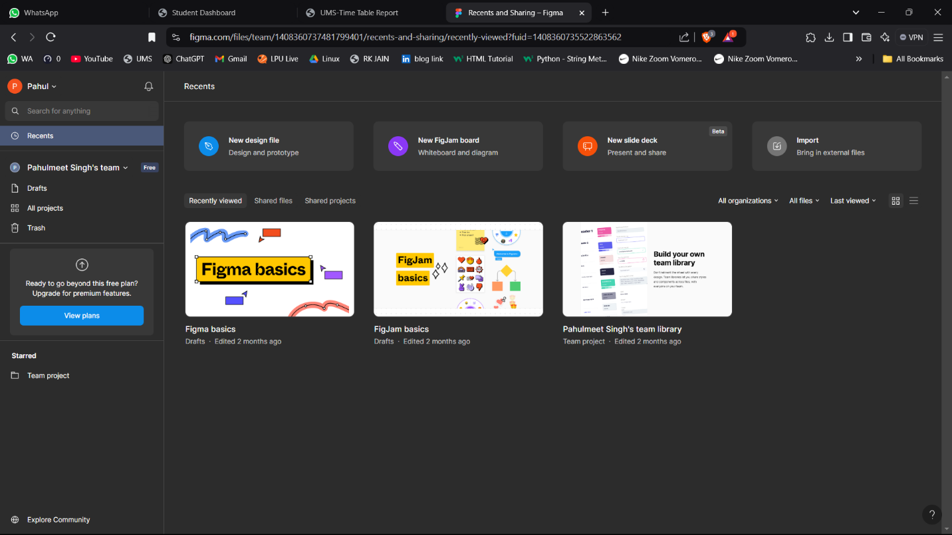

2.QUORA

PROFILE:

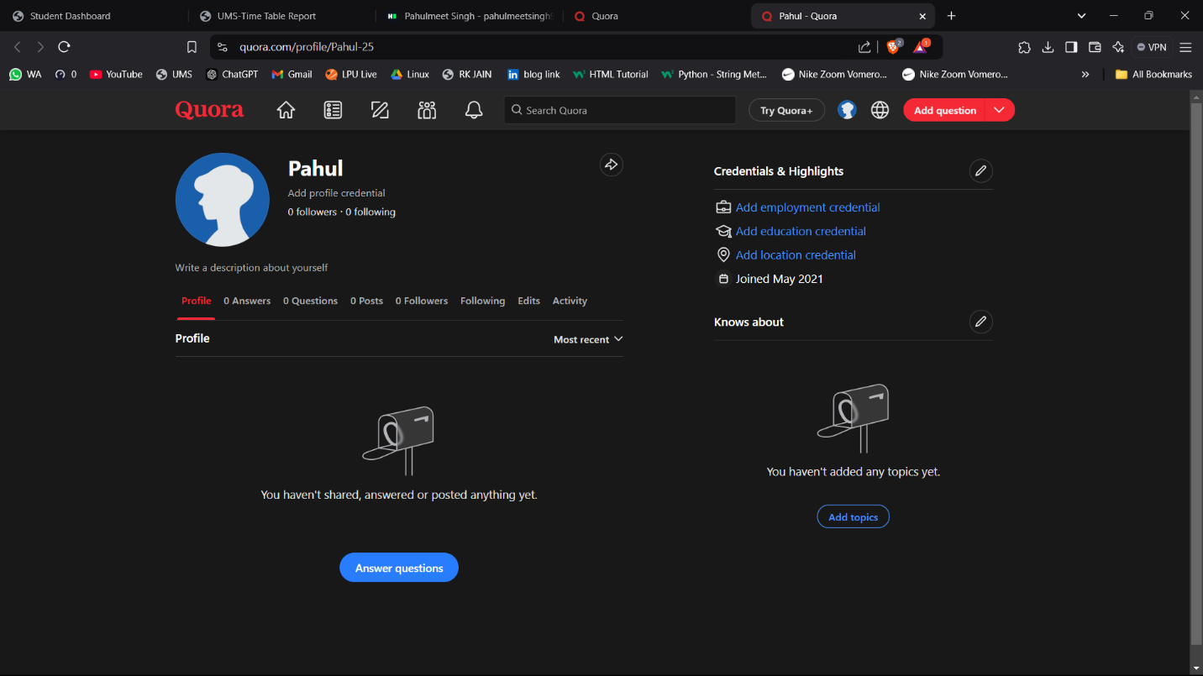

3.STACKOVERFLOW

PROFILE:

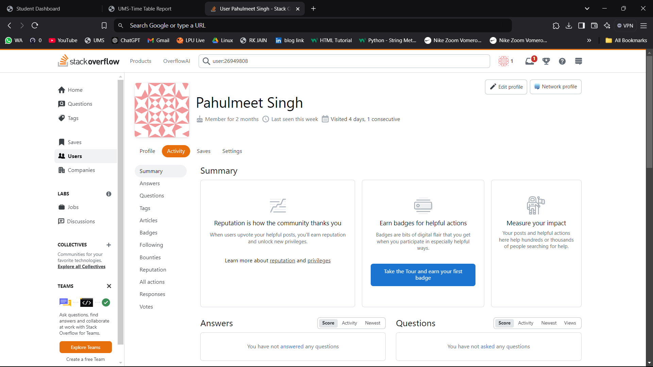

**4.HACKER RANK**

**Profile:**

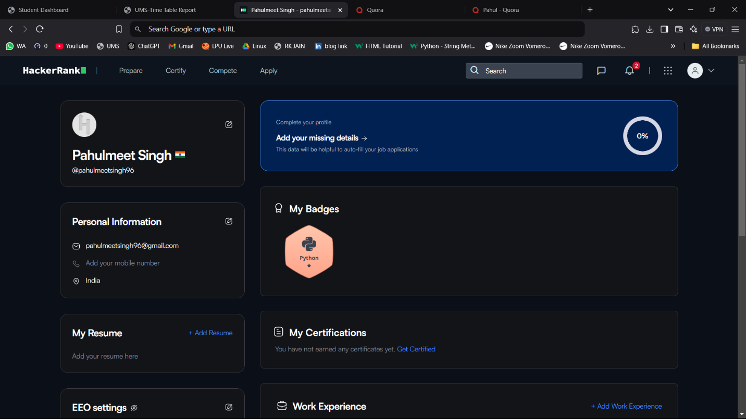

**5.HACKER EARTH**

**Profile:**

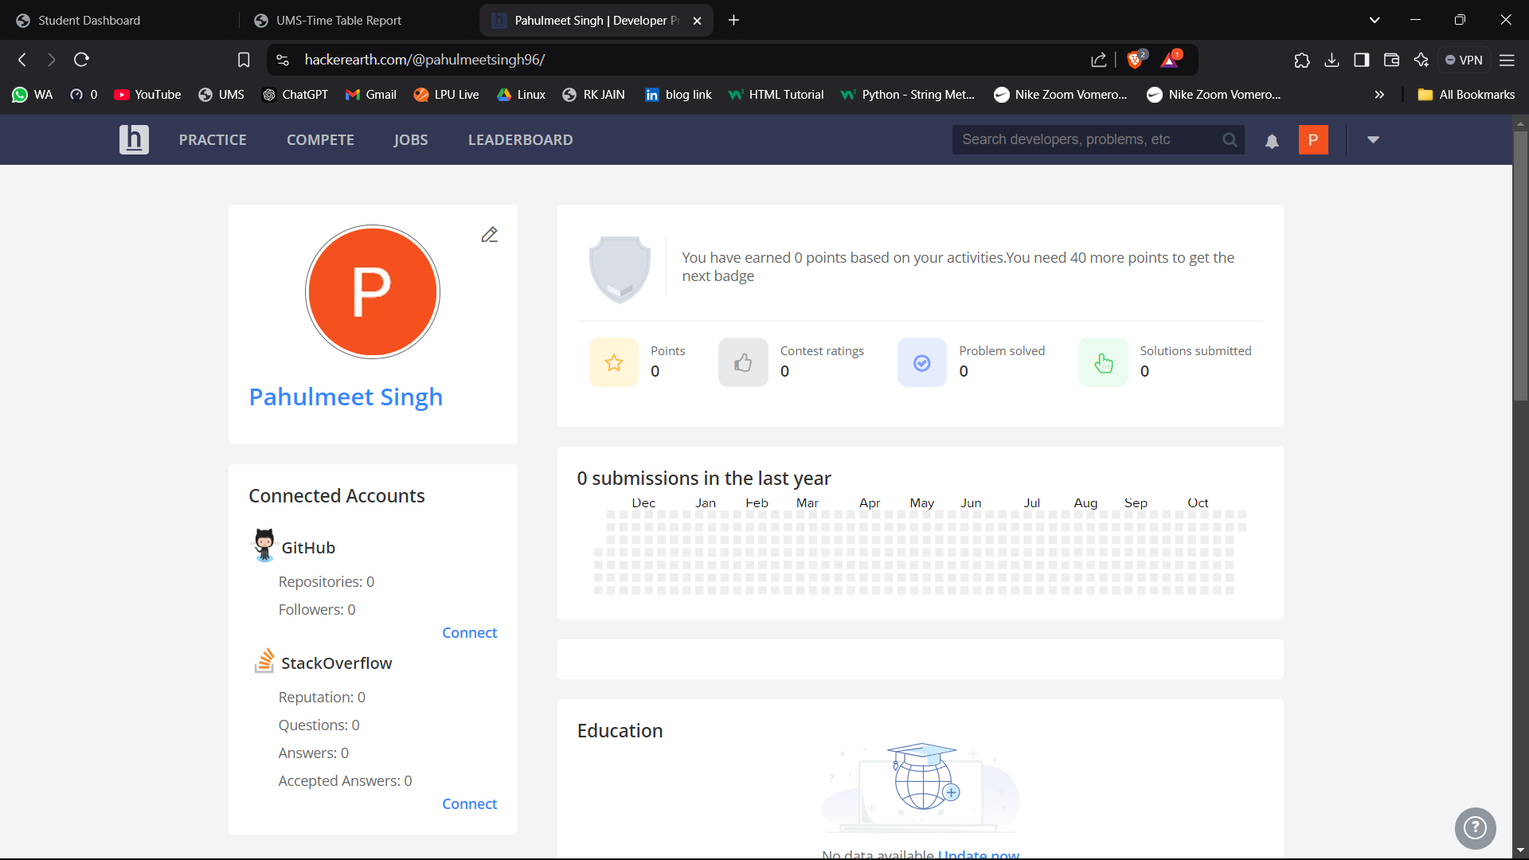

**6.GEEKS FOR GEEKS**

**Profile:**



**8. GITHUB**

**Profile:**

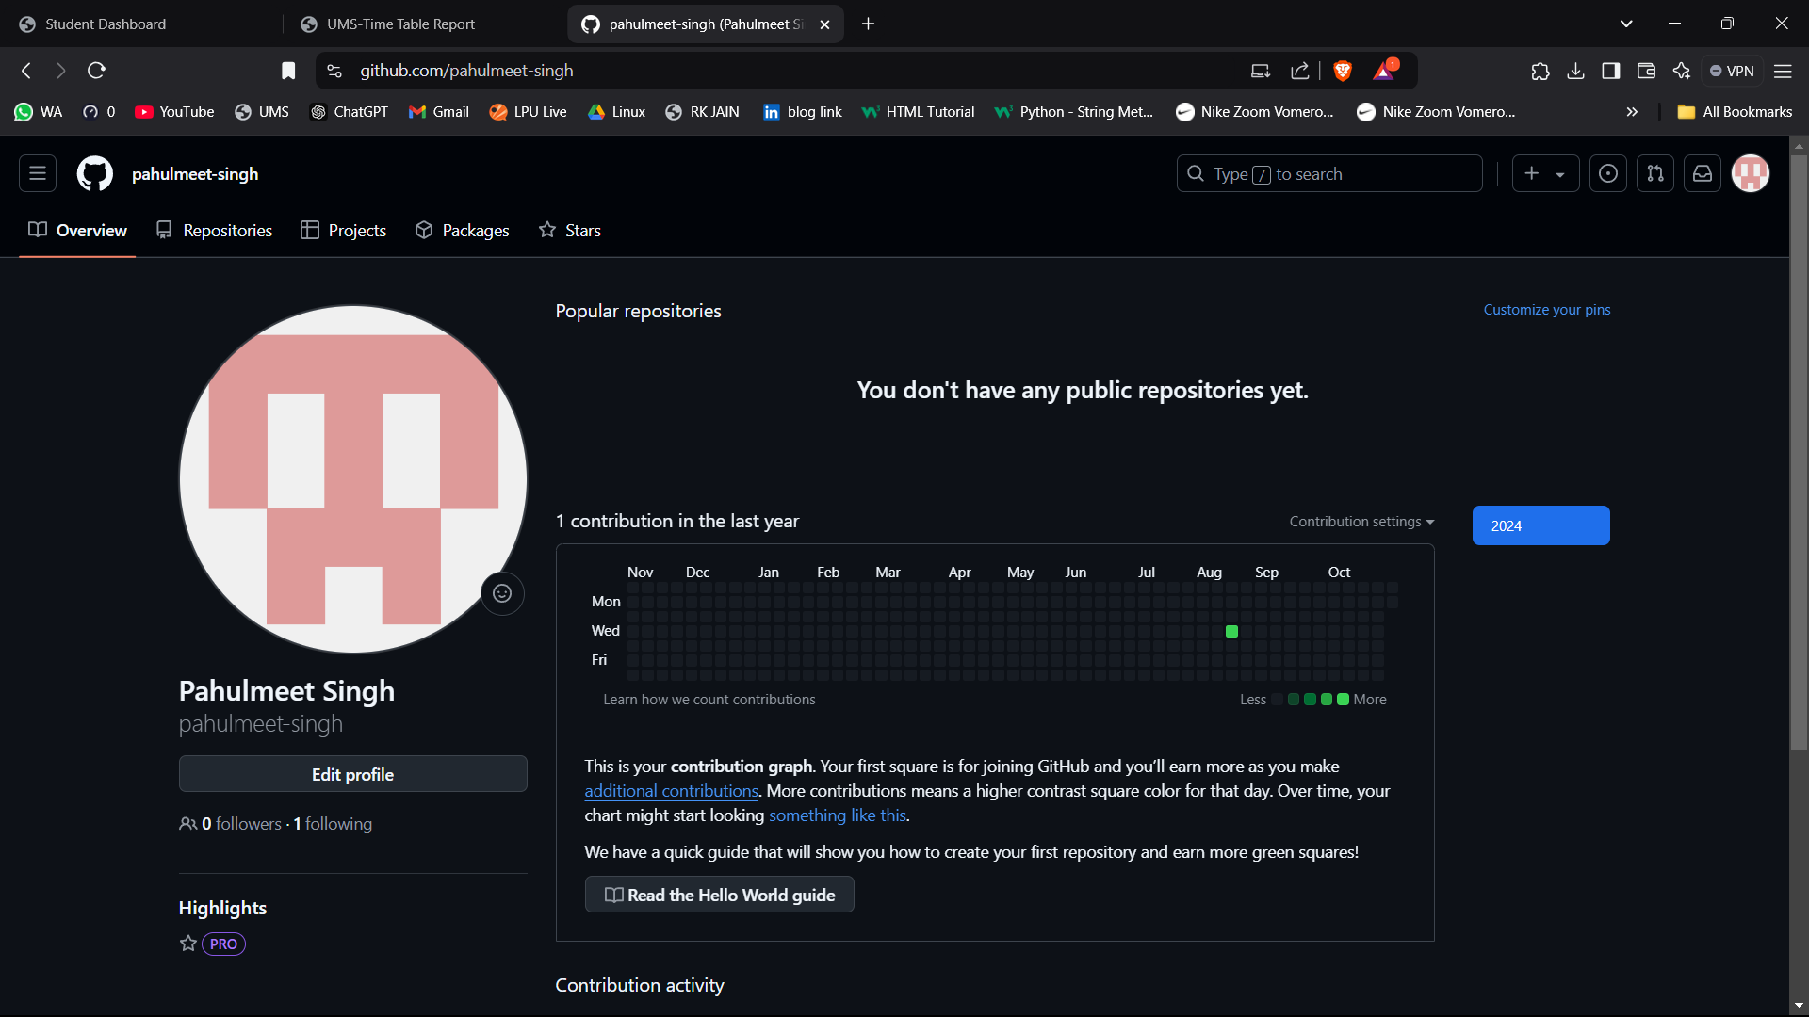

**10.LinkedIn**

**Profile:**

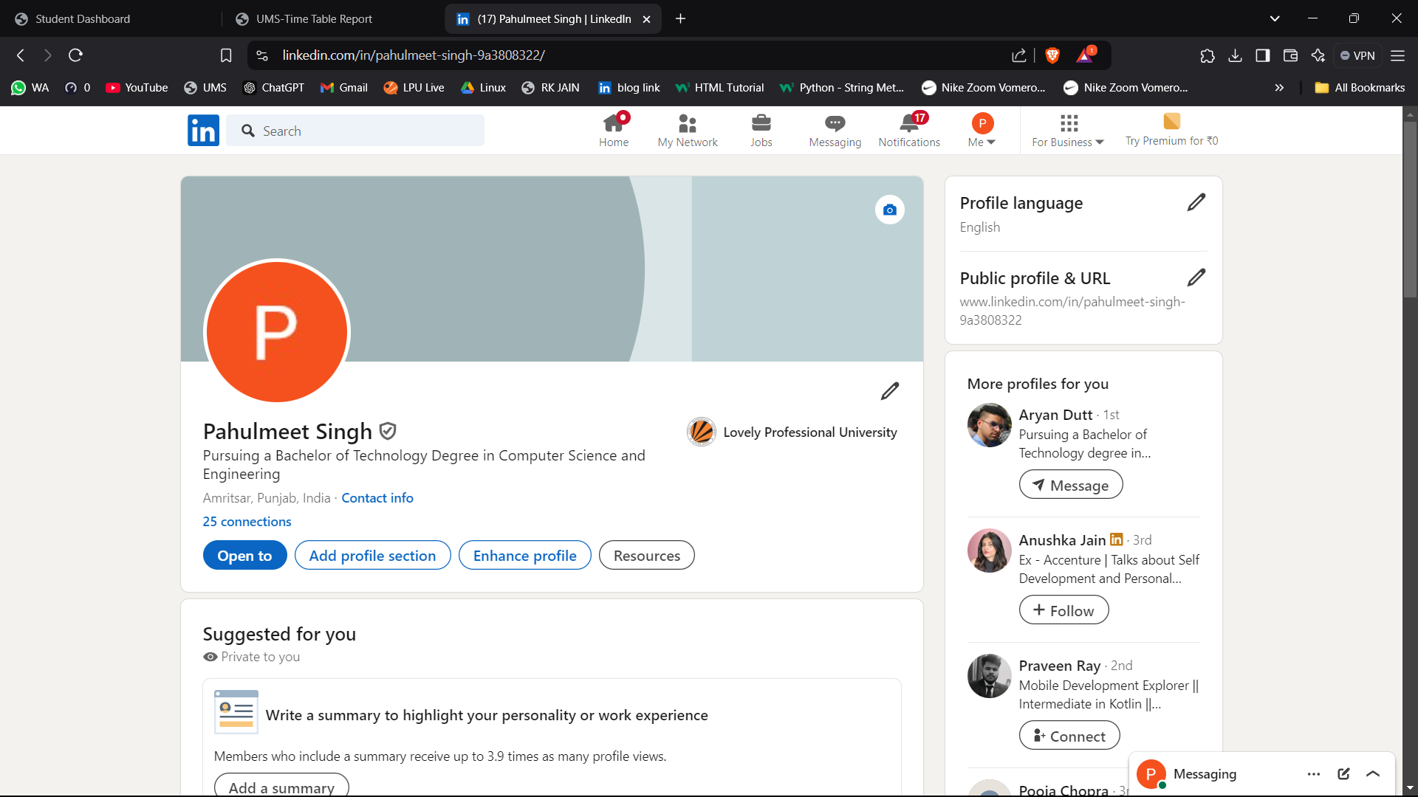

**11.MOOCS completed**

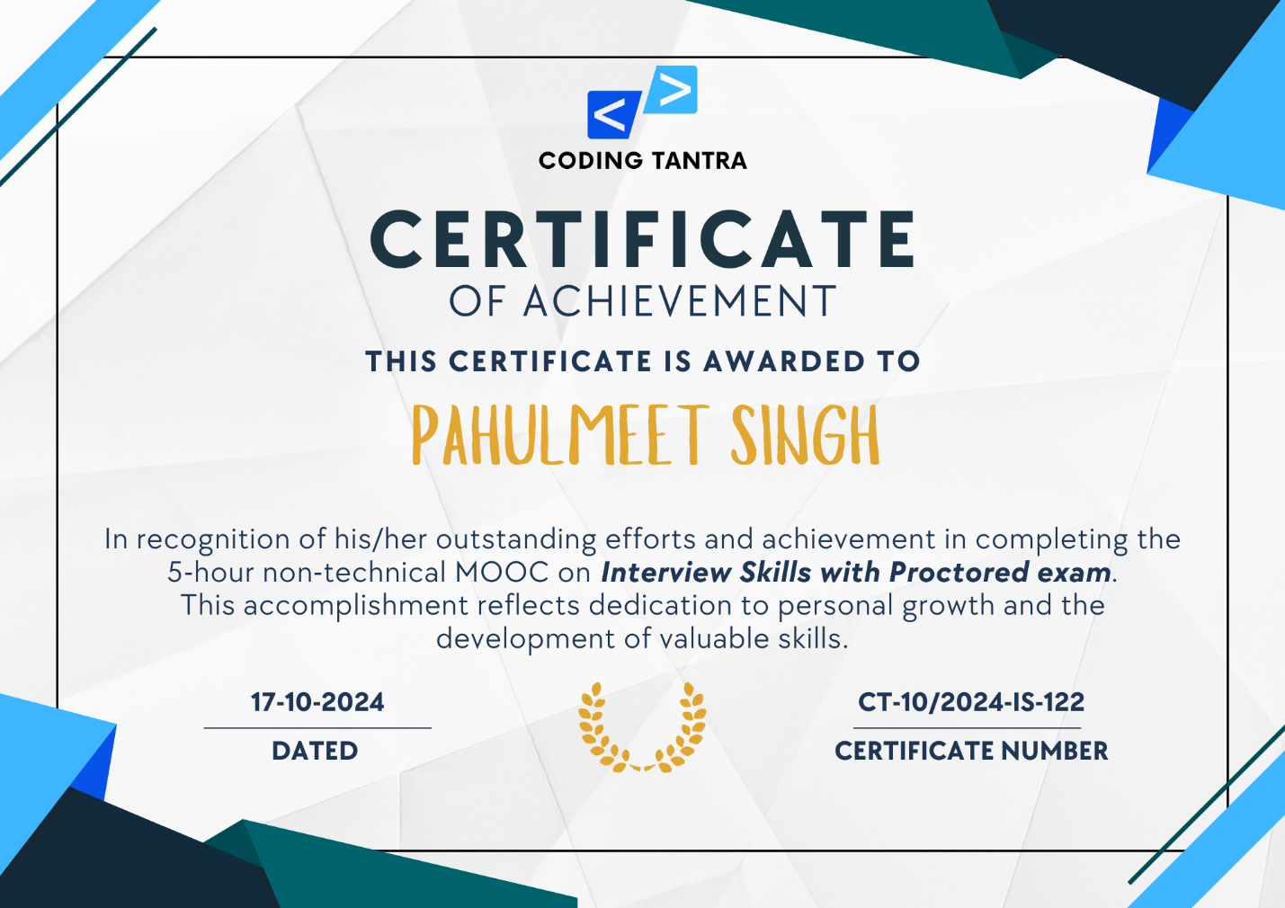

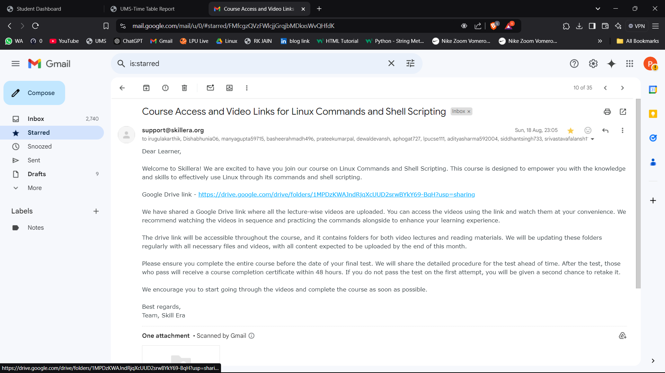

**12.Technical MOOC registration Link**

<https://codingtantra.com/ExploreInterviewSkills>

<https://skillera.org/ExploreCourses>